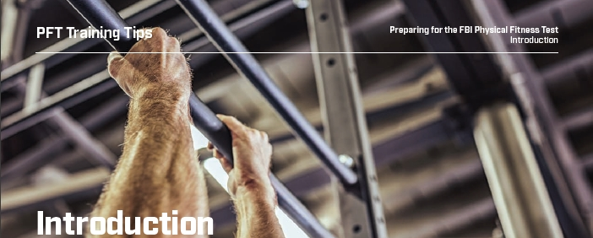

**Taking the First Step:**

When applying for a Special Agent position at the Federal Bureau of Investigation (FBI), one of the most daunting challenges for some applicants is the FBI’s Physical Fitness Test (PFT). However, rest assured — with the proper training, you can and will pass the PFT with flying colors!

To assist you on your journey, we have developed this training guide to help you build skills and strengthen the muscle groups essential to passing the four mandatory sections of the PFT — sit-ups, the 300-meter sprint, push-ups and the 1.5-mile run. We’ve also included training tips for a fifth event, pullups, required only for candidates in the Tactical Recruitment Program (TRP).

This guide provides detailed instruction, drills and photos depicting the proper form and technique to build strength and capacity.

You may apply without a passing score on the self-PFT — for now. But keep up your training, because if you’re accepted, you will need to pass the PFT soon!

An FBI Special Agent career is the opportunity of a lifetime and we’re looking for applicants from a wide range of educational and career backgrounds. Come join the more than 37,000 men and women who have answered the call to serve their country, protect their communities and uphold the Constitution. Good luck!